Here is screenshot of all the data size and throughput 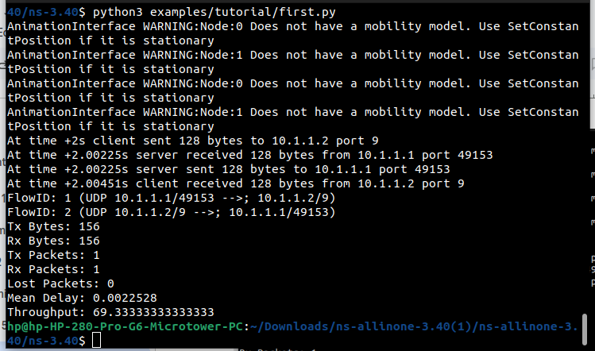

For the data size of 128bytes we get throughput of 69.33

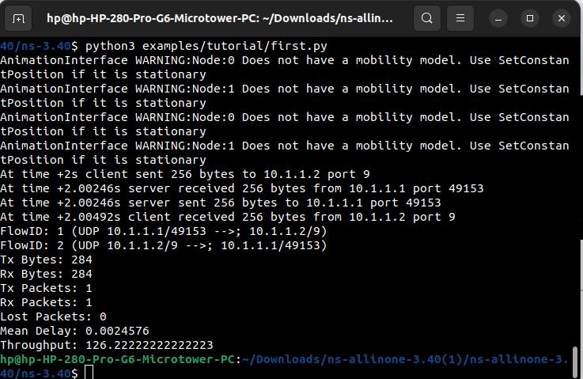

For the data size of 256bytes we get throughput of 126.222

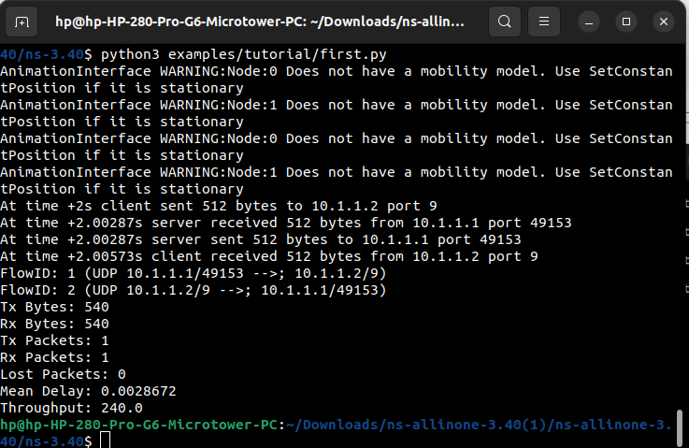

For the data size of 512bytes we get throughput of 240

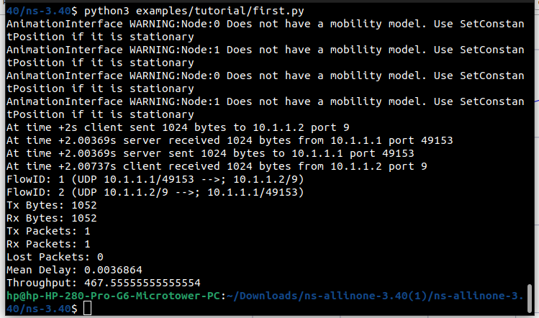

For the data size of 1028bytes we get throughput of 467.555

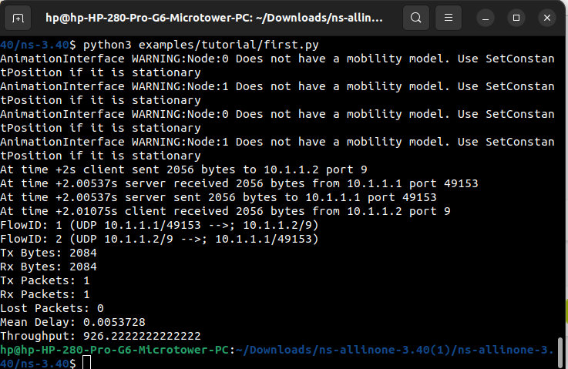

For the data size of 2048bytes we get throughput of 926.222

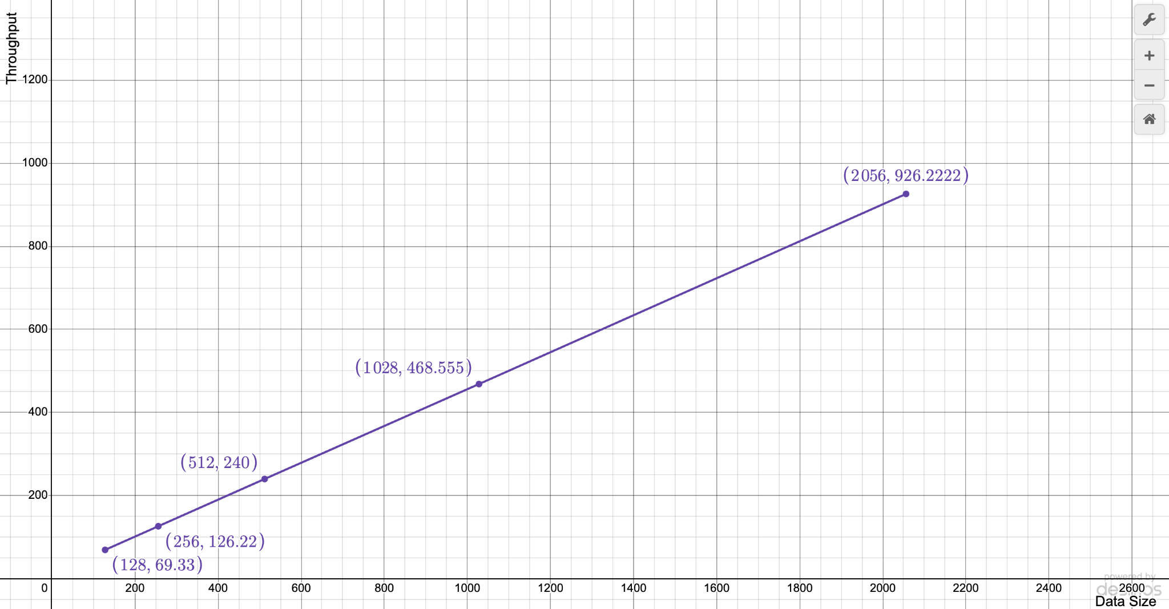

Here is the graph of throughput and datasize. X-axis represents the data size and Y-axis represents the throughput. As we can see this is a linear graph. If the data size is increased throughput is increasing linearly.